Rhetorical Analysis of Thor Odinson’s Visual Representation
Marvel have taken the box office by storm with their superhero film franchise that began back in 2008. Now, their movies and superheroes are known and loved worldwide. One of the primary superheroes, Thor Odinson (aka Thor), has been a fan favorite with three individual movies and main features in Avengers films. The character of Thor has arguably gone through the most transitions and adversity than any other Marvel superhero. With these changes come changes to Thor’s appearance and visual representation throughout the development of his character. In the following paragraphs, visual and culture-centered lens will be used to rhetorically analyze Thor throughout the Marvel movies that best show his transformation throughout the franchise. After putting the Marvel movies in chronological order of events, I will look at the rhetorical argument that Thor’s visual representation makes, as well as how the culture of that specific movie influenced the visual argument.
The Marvel franchise is a massive cumulation of work ranging from comic books, tv series, movies, and more. For this particular study, I will be focusing on the character of Thor as depicted from the Marvel Cinematic Universe Film franchise which is independently produced by Marvel Studios (Tillman). In this series of superhero films, Thor is a major character in Thor (2011), The Avengers (2012), Thor: The Dark World (2013), Avengers: Age of Ultron (2014), Thor: Ragnarok (2017), Avengers: Infinity War (2018), and Avengers: Endgame (2019). For this study, I will be looking at the movies that feature Thor’s most transformative moments. Film’s in this study will be Thor (2011), Thor: Ragnarok (2017), and Avengers: Endgame (2019).
Throughout this study, the rhetorical methods of visual lens and culture centered lens will be used to analyze Thor. According to Brummett in Rhetoric in Popular Culture, “The visual is a major way in which people develop a sense of self, of who they are. But it is also a major point of connection to society, a visual rhetoric appeals to shared visual experiences,” (pg. 184). Although visual rhetoric is more open to interpretation than traditional written text, authors still consider the same rhetorical aspects such as audience, context, purpose, tone, arrangement, and more. Brummett also points out, “Images, like language, have a structure—they appear in context—and they must be interpreted so as to extract meaning from them,” (pg.185). So, how does one interpret a visual image? For this study, I will be looking at the visual argument that Thor’s appearance makes. Aspects that will be considered are color, contrast, stance, main idea, message, and more.
Visual rhetoric will also be interpreted through the culture-centered lens. By determining how culture influences the visual of Thor, we will better understand the argument that the creators of Thor intended to make. The rhetorical method of a culture-centered lens leans on the idea that cultures are best understood by using methods of criticism and interpretation that arise from the cultures themselves. According to Burmmett, “Every culture contains its own method of critical analysis, its own questions and probes to be brought to bear on the artifact that is being examined. Such methods will be appropriate for understanding artifacts within, or peculiar to, that culture, particularly if we want to know what those artifacts mean for members of that specific culture,” (pg. 151). In other words, one needs put itself in the shoes of the people from a specific culture to determine the significance and meaning that a certain artifact has from that same culture. Something also important to understand about culture-centered criticism is that one must use caution while using it. Making claims about a culture different from yours should be done with care, and an understanding that they may see things differently than you think. To accomplish this, I will attempt to put myself in the culture that surrounds Thor in each movie and determine how that culture affects his look, and what argument his character is making based on his visual appearance.
Thor (2011)
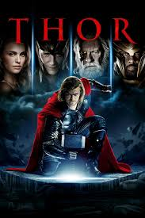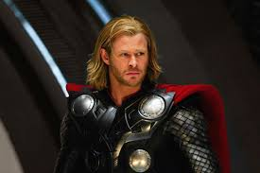
Audiences everywhere witnessed the presence of Thor for the first time in the original 2011 MCU film, Thor. “The God of Thunder” was seen by many as the most powerful superhero to come out of Marvel studios. Why was this? Because of the raw power and presence that Thor had. After studying and analyzing Thor’s appearance and visual representation in this film, there are many aspects that contribute to the powerful, super-human appearance of Thor. Starting from the head, Thor has long, blond, flowing hair. In preset day, long hair on men may not mean much; however, it used to mean a great deal. Long ago, especially from a biblical standpoint, long hair on men stood for power, strength, and holiness. In the same way that the biblical character Samson gains his strength through his hair, Thor seems more powerful and “god-like” with his flowing, blond, beautiful hair. Thor’s culture also emphasizes the notion that long hair depicts power and authority. In Thor’s alien civilization home, Asgardian, nearly all of the most powerful men have long hair including Odin, Ruler of Asgardian; Loki, brother of Thor; Heimdall, The Guardian of Worlds; and most Asgardian warriors. Another visual aspect that contributes to Thor’s rhetorical argument of himself is his red cape. Throughout the MCU movies, Thor’s cape serves no real purpose. It is not used to fly, shield, or any other superpower. So, what is the point to it? The most likely answer is to distinguish him among other superheroes in order to stand out. First, the color red is associated with power. Second, the cape has come to represent a number of things. A superhero cape could make, “characters look bigger and more menacing,” ("Why Do Most Superheroes Wear Capes?"). Also noted is the similarities of Thor’s cape with Superman’s cape which expresses, “a sense of majesty and a touch of mystery which helped to showcase the idea that he was otherworldly” ("Why Do Most Superheroes Wear Capes?"). Together, the color red and the cape make the rhetorical argument that Thor is unworldly, majestic, and powerful. A third main visual aspect of Thor is his notorious build. Of all the superheroes in MCU’s film series, Thor has the biggest build and definition of them all. Thor’s build obviously represents strength and power, but it also has other meanings as well. This visual aspect of his body may represent the human characteristics, along with his “unworldly” characteristics that represent his character’s appearance and personality as a whole. Yes, Thor’s muscles and figure are truly “godlike” and unlike any human on Earth; however, although Thor is from an alien civilization, he still has an actual human body made of flesh. This shows that although he may be from Asgardian, and has unique “unworldly” strength, his body, and later, personality, still resemble that of a human. The last main visual aspect of Thor in the first movie is Mjolnir, also known as, Thor’s hammer. Thor’s hammer is an important part of himself and is seen in most scenes with Thor. The obvious visual representation of the Hammer signifies power and destruction, but when looked at through the cultural lens, it means much more. Thor’s hammer was passed down by King Odin, his father, to signify that the throne will also be passed down to Thor. This hammer, when combined with its appearance and cultural significance signifies the power and strength of Thor, as well as his destiny that will eventually come. The above paragraph demonstrates the rhetorical argument that the character of Thor makes in Thor (2011) based on his appearance and how his cultural methods of interpretation perceives him as an Asgardian.
Thor: Ragnarok (2017)
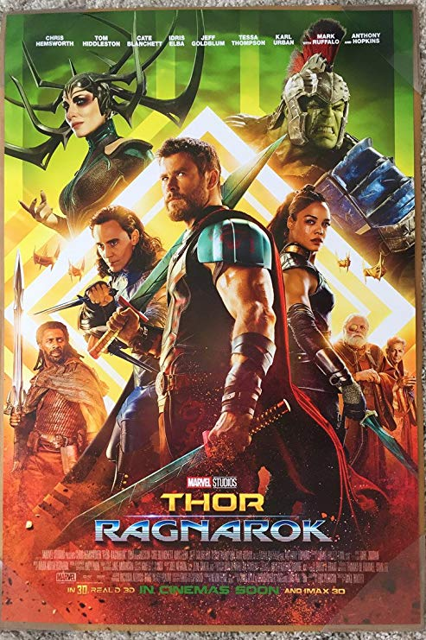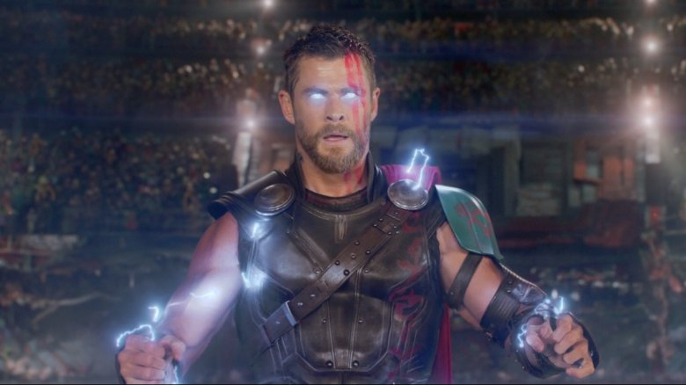
Although Thor’s character faced new enemies in different battles, the appearance and persona of Thor relatively stayed similar in The Avengers (2012), Thor: The Dark World (2013), and Avengers: Age of Ultron (2014). The next movie to show a major transition in Thor and his visual appearance was Thor: Ragnarok (2017). In this movie, Thor begins in chains, breaks free to travel to Asgard, travels to New York where he is sent through multiple portals, goes to Norway to speak to his father, is sent to the foreign planet of Sakaar, escapes and travels through “The Devil’s Anus” to return to Asgard, and finally is forced back to earth after the decimation of Asgard. To say that Thor went through major transformations, including his look, throughout this movie is an understatement. First, and perhaps most obviously, is the visual transformation of Thor’s signature hair. Hair is seen in some cultures as an extremely important part of a person. According to Synnott in his article "Shame and Glory: A Sociology Of Hair", he explains that, “Hair is perhaps our most powerful symbol of individual and group identity – powerful first because it is physical and therefore extremely personal, and second because, although personal, it is also public rather than private,” (pg. 381). Synnott also states that, “Finally, hair is malleable, in various ways, and therefore singularly apt to symbolize both differentiations between, and changes in, individual and group identities,” (pg. 381). Based on this study, Thor’s change of hair is a direct link to his change of character. All of Asgardian’s high power individuals have long hair, and without it, Thor does not visually fit in as a person in power in Asgard. Through the cultural lens of the Asgardians, Thor’s people, the cutting of his hair could signal the shift from being their future King to choosing his own path in life. Although that shift does not happen in this film, it is slowly understood throughout his movies that Thor was never truly meant to rule over the Asgardian people, but to rather rule and protect all people outside of any restrictions that the position of “King” would have. Additionally, the visual representation of Thor having his hair cut could represent freedom from bondages that he had. It is in Thor: Ragnarok, after Thor’s hair is cut, that he realizes the true, full power that lies within him. Another visual aspect of Thor in the film is his loss of his eye in his battle against Hela. This visual change is the last major loss of the character after he loses his hair, his hammer, and then his eye. His character who started the film as an all-powerful “god” with his trusted weapon and god-like features is slowly stripped down to, “...create a broken version of the character. At the end, he sort of becomes a refugee” ("Chris Hemsworth Says...”). Through this new visual representation of Thor, we see a much different character than we were previously exposed to in his prior movies. Through the loss of some of his most notorious attributes, Thor is truly a new person by the end of Thor: Ragnarok, and on a different path than the one previously set out before him. Thor no longer fits his culture’s ideological “look” of an Asgardian King and continues on in the next movies on a different path than Asgardian Royalty.
Avengers: Endgame (2019)
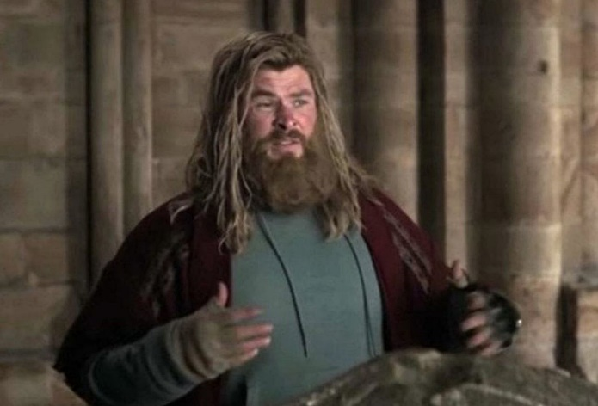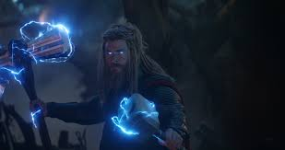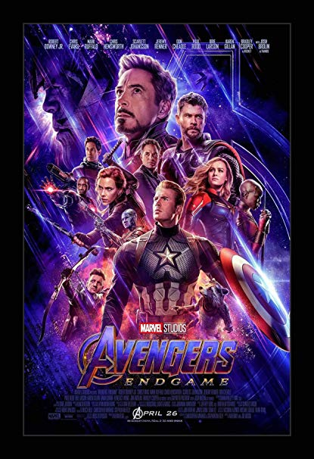
The last, and most extreme transformation of Thor in the MCU film franchise occurs in Avengers: Endgame. Thor is featured in the film for the first time five years after Thanos’ victory which depicts a very different Thor than his previous character. The visual rhetorical aspects of Thor combine to form his new identity of an obese, defeated, depressed, washed-up superhero. Thor has completed lost his super-hero persona and costume, figuratively shedding his responsibility that came along with it. Why do the producers show Thor in such terrible conditions after the defeat from Thanos more than any other MCU hero? Perhaps it is goes along with Thor’s visual representation throughout his film franchise. Thor’s outward visual representation of self is constantly changing to match his inward identity. In Avenger: Endgame, Thor’s outward appearance represents his inward feelings of defeat, guilt, and depression. Perhaps it also signifies Thor’s ongoing progression from “Asgardian King” to human – a theme seen in every Thor independent film. The visual change to Thor’s body shows the transformation from a “god”, to a human body that has been neglected due to mental illnesses; aiding in the perception that even the strongest people suffer from these diseases. Thor has also, figuratively and literally, lost his “edge” as a warrior by growing his hair into a disheveled, overgrown mess. Until the end of the film, Thor’s outward appearance depicts a man that the world has beaten down, and very nearly almost broken. It isn’t until the ending battle scene, when Thor sees Thanos again, that his outward image is yet again changed. Whether it be a new sense of motivation, a sign of hope, or a recognition of his responsibility, Thor, although his baggage still evident, regains parts of his previous persona of one of the most powerful superheros of the MCU. It is this person, a character that still carries the scares and markings of hardship, but who evolves as a person and hero to become who they were truly meant to be, who we are left with at the end of the film
The above paragraphs use the visual lens, pared with the culture-centered lens, to rhetorically analyze the character of Thor throughout the MCU franchise films. As arguably the most transformative superhero in the series, Thor’s visual aspects and appearance match that change to reflect the character’s inward progression with his outward image. Some of Thor’s main visual arguments come from his hair, his costume, his build, his weapon, and more. Asgardian culture also aids in the understanding of the visual changes that Thor goes through. By understanding the significance of aspects in their culture, such as long hair and a weapon passed down from a father, we are better able to understand the true significance of Thor’s visual changes in regard to those things. In Avengers: Endgame, we are left with a Thor that has been beat down, but one who has also overcome and is working on becoming his true self at the “end” of the MCU saga... for now.

Work Cited
Brummett, Barry. “Varieties of Rhetorical Criticism.” Rhetoric in Popular Culture, fifth edition,
SAGE Publications, 2018, pgs. 147-214.
"Chris Hemsworth Says Thor Will Still Be In Avengers: Infinity War". EW.Com, 2019,
https://ew.com/movies/2017/11/04/thor-ragnarok-chris-hemsworth-infinity-war/.
Synnott, Anthony. "Shame and Glory: A Sociology Of Hair". JSTOR, vol 38, no. 3, 2019, pp. 381-
384., Accessed 10 Dec 2019.
Tillman, Maggie. "MCU Timeline: The Order To Watch Every Marvel Movie And Show". Pocket-
Lint, 2019, https://www.pocket-lint.com/tv/news/disney/147514-mcu-timeline-best-marvel-movie-show-viewing-order.
"Why Do Most Superheroes Wear Capes?". I'm A Useless Info Junkie, 2019,
https://theuijunkie.com/why-most-superheroes-wear-capes/.

